**Test Plan**

|  |  |  |  |
| --- | --- | --- | --- |
| **Test Serial No** | **Name of Test** | **Criteria for Test Name** | **Expected Result** |
| 01 | Unit Test | Add news  Add weather  Add event | Each testing will work properly |
| 02 | Integration Test | Sending email notification during form submission | Integration testing worked properly |
| 03 | Functional Test | Event Scheduling  Real time weather  Show latest News | Will be done the functional testing properly. |
| 04 | Usability Test | Dropdown Menu  Navigation Bar | The items will be added in the perfect positon. |
| 05 | Security Test | Authentication of User  Checking of URL  SQL Injection | Each testing will display the result properly. |
| 06 | Browser Compatibility Test | Google Chrome  Mozilla Firefox  Internet Explorer | Will be run in the different browser. |

**Test Cases**

**01. Unit Test**

|  |  |  |  |  |  |
| --- | --- | --- | --- | --- | --- |
| **No** | **Title** | **Pre-Conditions** | **Test Steps** | **Expected Result** | **Actual Result** |
| 1.1 | Add news | Login First | Need to open the website | Column will be added. | Column Added Successfully |

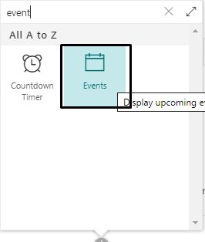

**Figure: Add event**

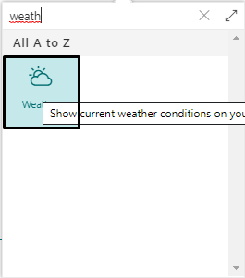

**Figure-: Add weather**

**02. Integration Testing**

|  |  |  |  |  |  |
| --- | --- | --- | --- | --- | --- |
| **No** | **Title** | **Pre-Conditions** | **Test Steps** | **Expected Result** | **Actual Result** |
| 2.1 | Sending email notification during form submission | Login First | Going to the website needed to submit the form. | Email will be added | Email is send |

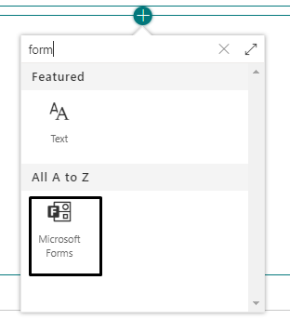

**Figure: Form adding process**

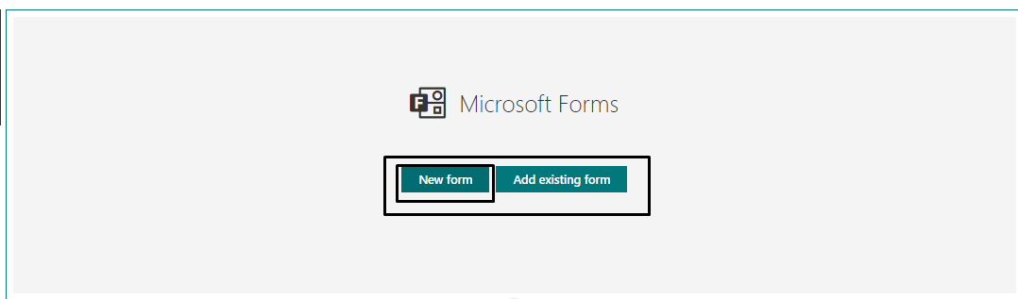

**Figure: Form Creation**

**03. Functional Testing**

|  |  |  |  |  |  |
| --- | --- | --- | --- | --- | --- |
| **No** | **Title** | **Pre-Conditions** | **Test Steps** | **Expected Result** | **Actual Result** |
| 3.1 | Show latest news | Login First | Firstly going to the site then click this button | All the latest news  Will be shown | News Shown  Successfully |

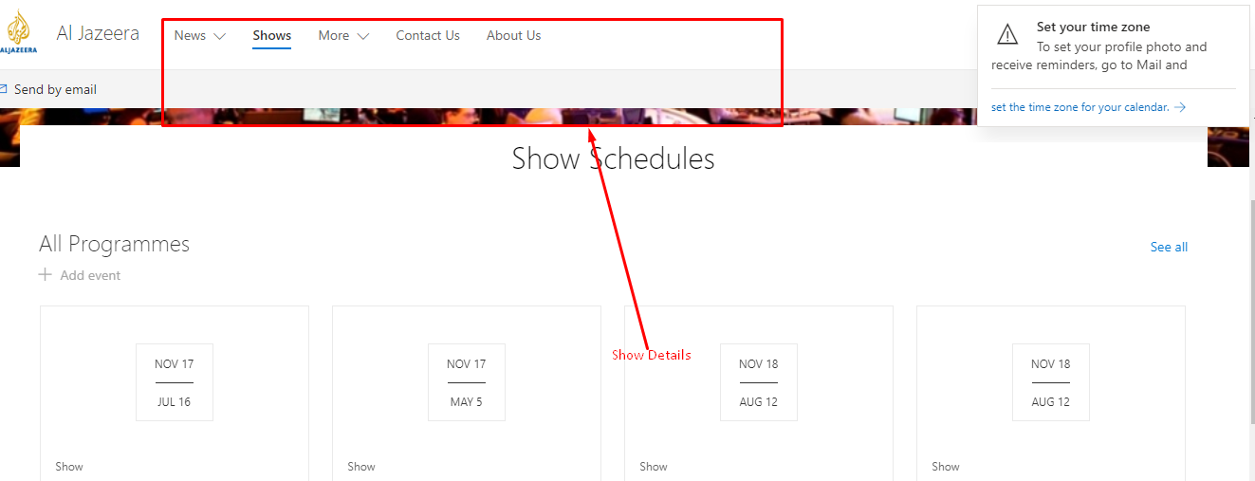

**Figure: Show Schedules**

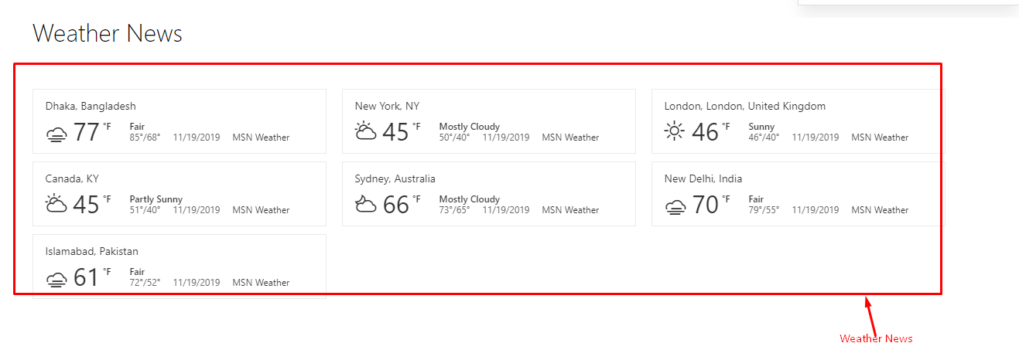

**Figure: Show Weather News**

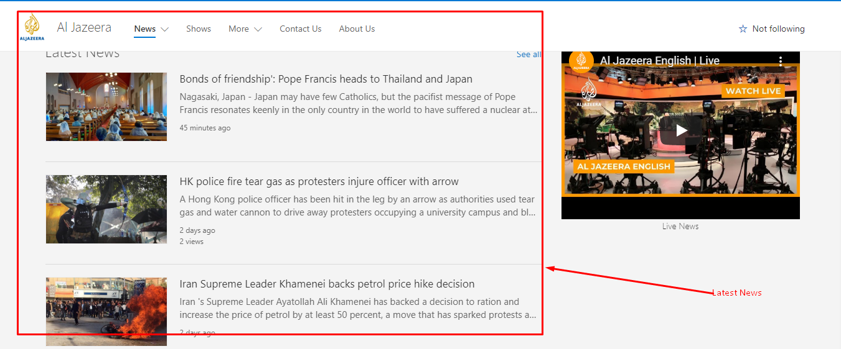

**Figure: Latest News**

**04. Usability Testing**

|  |  |  |  |  |  |
| --- | --- | --- | --- | --- | --- |
| **No** | **Title** | **Pre-Conditions** | **Test Steps** | **Expected Result** | **Actual Result** |
| 4.1 | System UI usability | Login First | Going to the site it is needed to check the button,  Dropdown etc. | Will be work properly the button, navigation bar | Done the feature properly. |

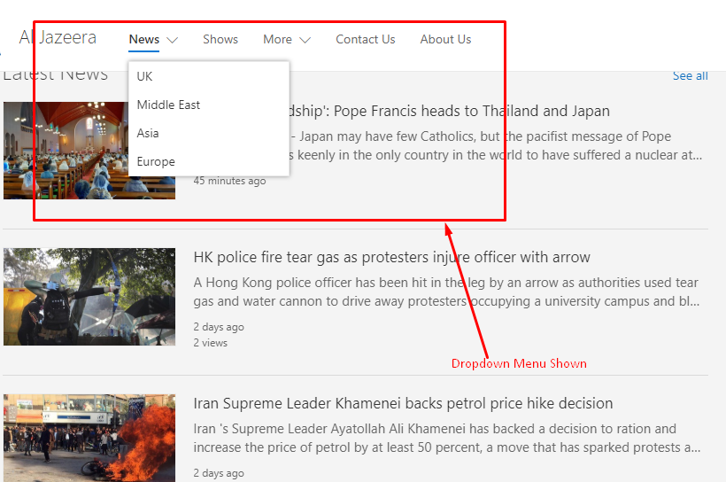

**Figure: Dropdown menu shown**

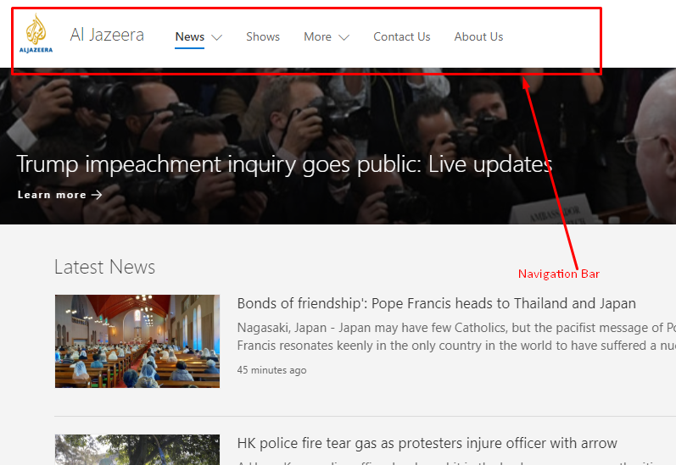

**Figure: navigation bar shown**

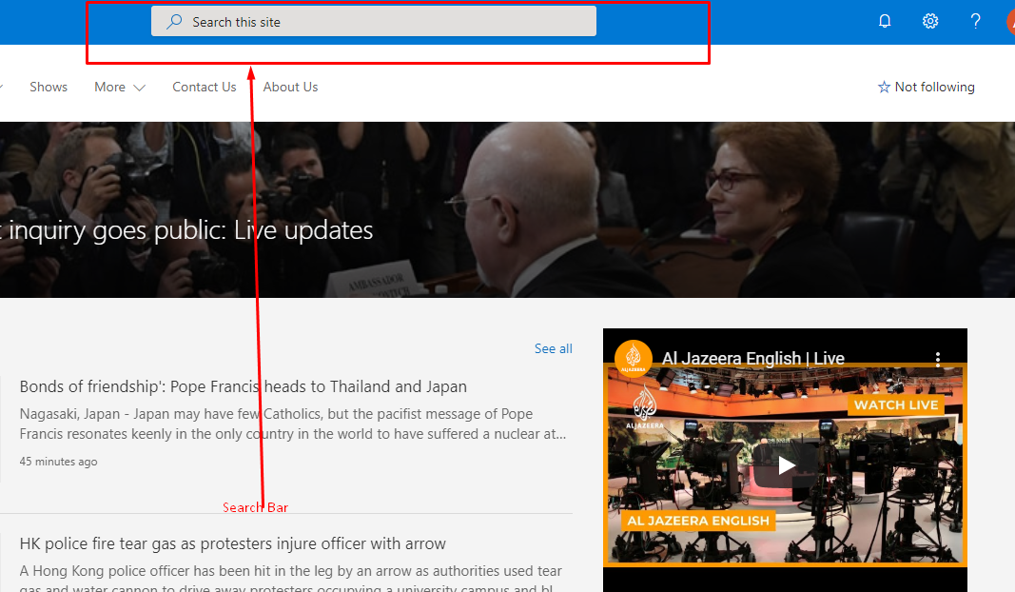

**Figure: Search Bar**

**05. Security Testing**

|  |  |  |  |  |  |
| --- | --- | --- | --- | --- | --- |
| **No** | **Title** | **Pre-Conditions** | **Test Steps** | **Expected Result** | **Actual Result** |
| 5.1 | Authentication of user | Go to the login page | Input the email digit  Then input the password digit  Then hit the login button | If the email and password is given properly then user will be logged in | User logged in successfully with proper email and password. |

**Figure: navigation bar shown**

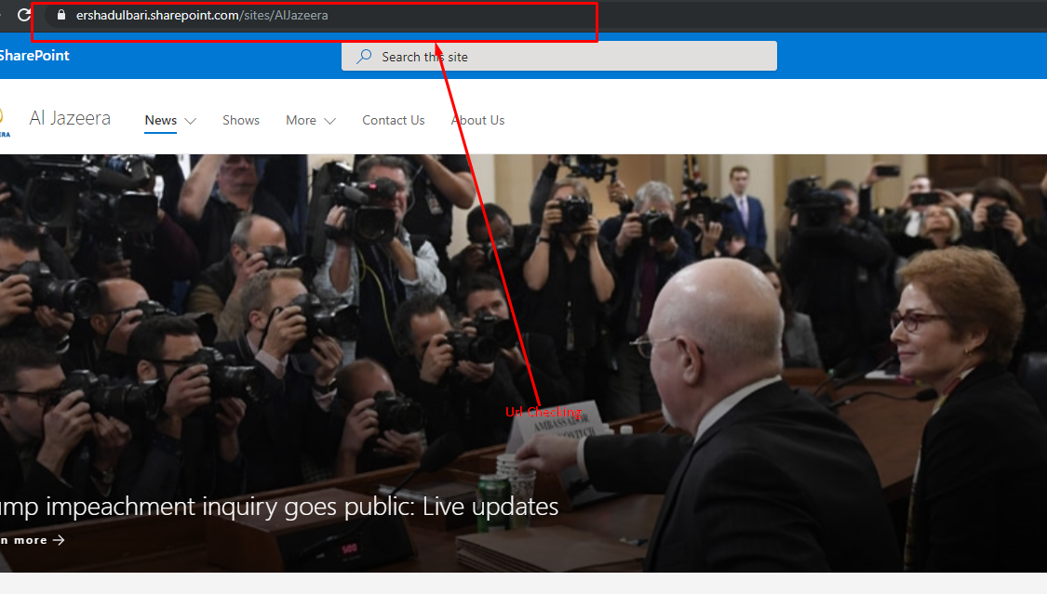

**Figure: URL Checking**

**06. Browser Compatibility Testing**

|  |  |  |  |  |  |
| --- | --- | --- | --- | --- | --- |
| **No** | **Title** | **Pre-Conditions** | **Test Steps** | **Expected Result** | **Actual Result** |
| 6.1 | Cross browser testing | It is needed to open the site in various browser | Firstly open the site in different browser.  Then evaluate and differentiate the site within the different browser. | System will be run without having problem in the all browser | No problem occurred during run the site in different browser. |

**Test Log**

|  |  |  |  |  |
| --- | --- | --- | --- | --- |
| **Test Serial No** | **Name of Test** | **Specification** | **Outcome** | **Result** |
| 01 | Unit Testing | All the units of the system has been checked properly. | Properly worked all the units. | Properly Done |
| 02 | Integration Testing | The integrated portion of the system has been checked and tested properly. | Successfully worked. | Properly Done |
| 03 | Functional Testing | The required functionality has been tested and checked in a proper way. | All the functions of the system worked properly. | Properly Done |
| 04 | Usability Testing | For the usability purpose of the system the appropriate navigation bar, dropdown menu and search bar has been created and tested in a proper way. | All the usability function worked properly. | Properly Done |
| 05 | Security Testing | All the issues that can cause security threat for the system is tested and checked. | This testing helped the system to prevent from various security threat. | Properly Done |
| 06 | Browser Compatibility Testing | The system had been run in different browsers to test its browser compatibility. | The system ran properly in the browser. | Properly Done |